**PART B**

**Aim of The Project:**  Test Case for ATM Machine Software

**Brief Description:**

* ATM project helps us to access our bank account from any place (ATM center) .
* It helps us to withdraw money from bank account and also to check bank balance, etc.
* The project is fully secured with password/pin to access the account
* The project consists of 10 modules.
* The withdraw modules helps to remove money from bank account.
* The deposit module helps to deposit money in bank account.
* The check balance module allows you to check the current balance in your account
* With the help of quit module, you can exit from your account
* The Test Cases Designed for the application helps us to check if all modules of the application are functioning properly.
* The Project Contains 10 Test Cases.

**Aim of Micro Project:**

The Micro-Project Aims To: -

* Study the basic features of test case.
* Study various component of test case like test case id, test case description, Actual result, Expected Result, etc.
* Study the basic structure of test Case table.
* Test various modules of Atm Application.

**Course Outcome Integrated:**

1. Prepare Test Plan for Application.
2. Prepare Test Cases for Different Types and Levels of Testing.
3. Apply Various Software Testing Methods.

**Actual Procedure Followed:**

1. **Group Formation: -**STE Is A Subject That Teaches Us Some Important Concept About Software Testing That Helps To Find Out Bugs And Defects In A Software**.** The Basic Aim Of Micro- Project Is To Accelerate The Attainment Of The Various Outcome In The Course. In The First 2 Weeks Of December The Subject Was Introduced. The Syllabus As Well As Detail Of Micro-Project Was Discussed. A Group Of 10 Members Was Formed And The Group Leaders Were Selected. The Schedules Of Plan “A”,” B” & “PRESENTATION OF MICRO-PROJECT” Were Finalized. The Various Micro-Project Topics Related To Subject Were Discussed Our Guide Gave Us The Opportunity To Select The Topic Of Our Choice.
2. **Finalization of Micro-Project: -** After Attending The Lectures For 2 Weeks. We Selected The Topic For Micro-Project. We Discussed The Topic With Our Guide Regarding The Concept Which We Are Going To Apply In The Project. We Individually Tried To Explain The Basic Platform Of Project.
3. **Planning: -** After Finalization Of The Project We Started Working On The Project. We Started The Planning Phase. We Discussed Among Ourselves Regarding The Resources Such As Testing Material, Software Requirements, Etc. In This Week We Completed ‘PART A PLAN’ Of The Micro-Project Which Is Nothing But An Initial Description About The Project. We Submitted It To The Guide.
4. **Module Distribution &Analysis Part: -** Once The Planning Was Over Regarding Resources, Etc. We Finalized The Module Which. We Will Be Testing. According To Members We Distributed The Module. We Started The Analysis Of Project.
5. **Design Part: -** In This Part We Focused On Designing The Test Case Table Structure. We Planned To Apply Some Formatting To Give An Attractive Look To The Structure.
6. **Implementation: -** In The Week We Actually Started The Technical Phase. In This Phase We Technically Applied The Formatting As Decided. The Test Cases For Each Module Which Was To Be Tested Was Sorted. Each Member Was Designing The Test Cases For The Module Which Was Assigned To Them. Finally, The Project Was Within The Schedule Time.
7. **Presentation: -** In This Week We Had To Present The Micro-Project . Each Member Of Group Presented Their Own Parts With Confidence In Front Of Guide. She Asked Us Various Queries Regarding The Topics. We Explained Her About The Various Components Of Test Case Table . She Asked Us To Do Some Changes Regarding Some Topics.
8. **Submission: -** This Week Was Submission Week. We Submitted Our Project Along With ‘Part A & B Plan’ To The Guide. We Also Submitted The Hard Copies And Soft Copies Of Project To The Guide

**Actual Resources Used:**

|  |  |  |  |  |
| --- | --- | --- | --- | --- |
| **Sr No** | **Name of Resources Required** | **Specification** | **Quantity** | **Remarks** |
| 1 | Computer | **Processor-**Amd  **Hard Disk-**2 Tb  **Ram-**16gb  **Operating System-**Windows 10 Pro | 1  1  1  1 | Hardware Used |
| 2 | Microsoft Excel | MS Office 2010 | -- | Software Used |
| 3 | Application | ATM Software | 1 | Application to Test |

**Output of Micro-Project:**

1. Application That Was Tested:

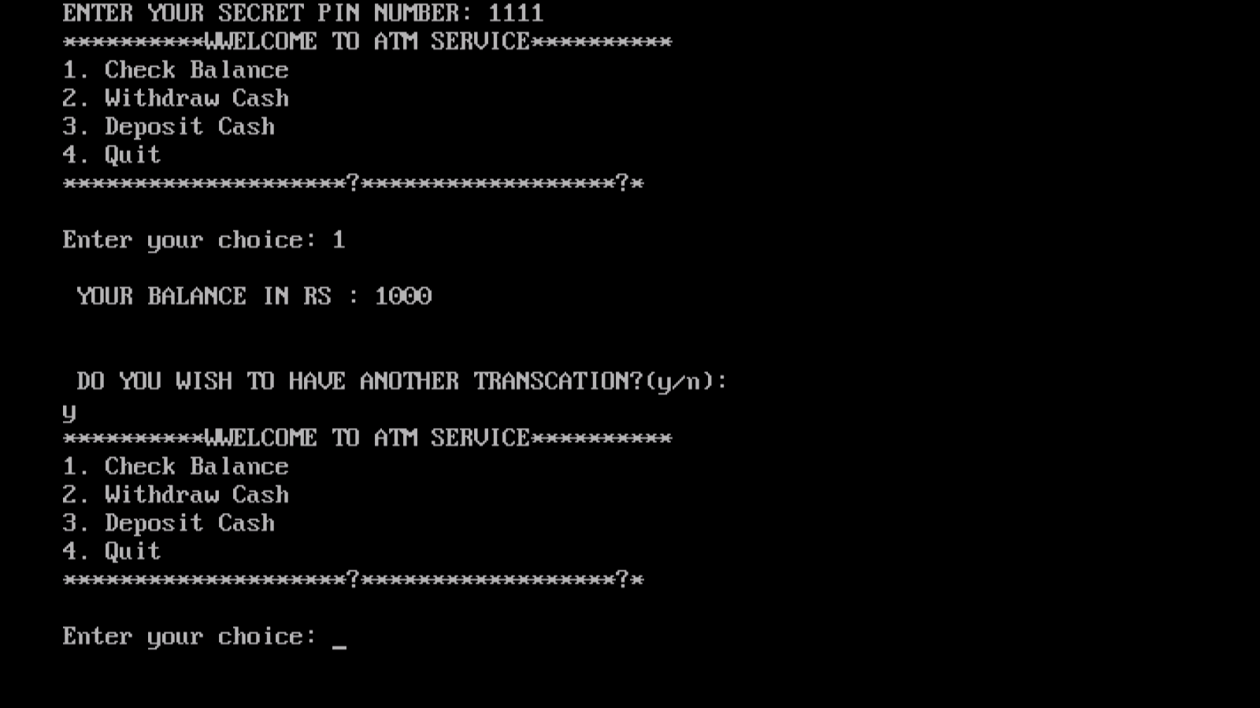

**References:**

We do have used a few references during the process of building our project. The references used are from Websites, Books etc.

The references used are:

* **Websites:**

1: Www.Softwaretestingsoftware.com.

2: [www.en.wikipedia.org](http://www.en.wikipedia.org/wiki/Operating)

3: www.Selenium.com.

* **Reference Books:**

1: Software Testing

2: Software Testing Principals and Practices

**Skill Developed/Learning Out of This Micro Project:**

* Since we worked in a group, we developed the skill of ‘TEAMWORK’ in us
* We learnt in brief about various component of Test Cases such as Test Case ID, Test Data, etc.
* We learnt to design Test cases For Application.